<https://www.slideshare.net/CezaryPodkul/the-art-science-of-the-comment-request-for-data-journalism-stories>

Rob Barry is co-chief of the investigative data journalism unit at The Wall Street Journal.

Cezary is a reporter at ProPublica, where he specializes in telling data-driven news stories focusing on finance.

Sarah Ryley is an investigative reporter at the New York Daily News.

(I didn’t go to this session, but saw the slides link and these notes on Twitter)

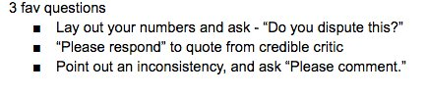

<http://ire.org/events-and-training/event/2702/3010/>